1. Format all cells -> Autofit column width
2. No duplicate IDs found
3. Inconsistencies in descriptions – capitalizations and missing phrases

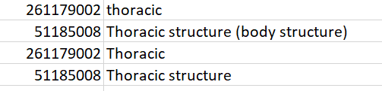

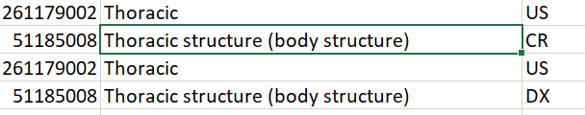

Fixed using find and replace

1. No missing values
2. Garbage characters present in values

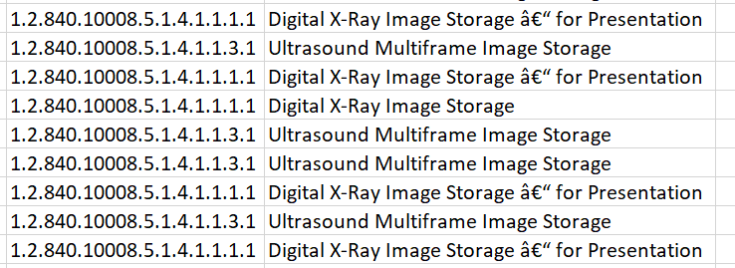

1.2.840.10008.5.1.4.1.1.1.1 sop code = Digital X-Ray Image Storage – For Presentation

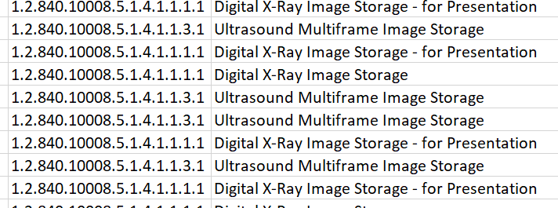

Furthermore,

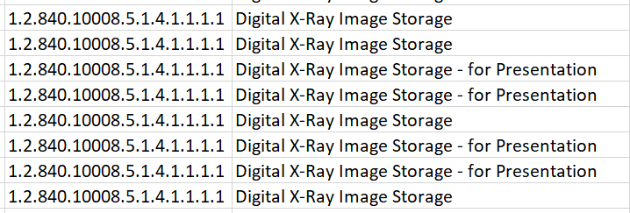

Some record miss ‘- for Presentation’ (according to DICOM standards)

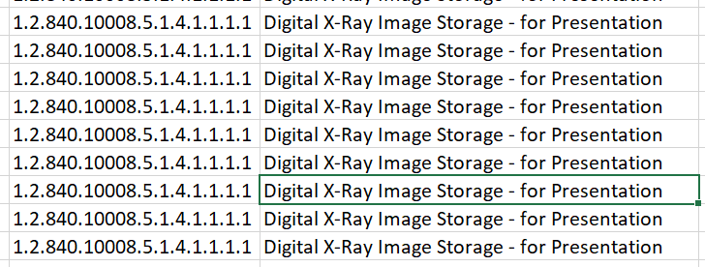

1. Set DATE as date format